Crawler written in python. WIll download apps from windowsphone.com in the /app directory.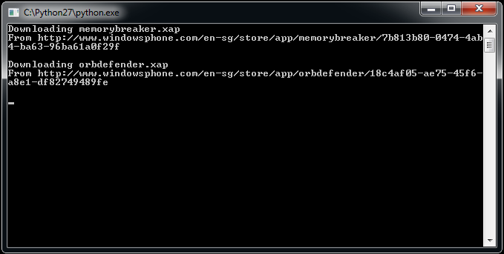

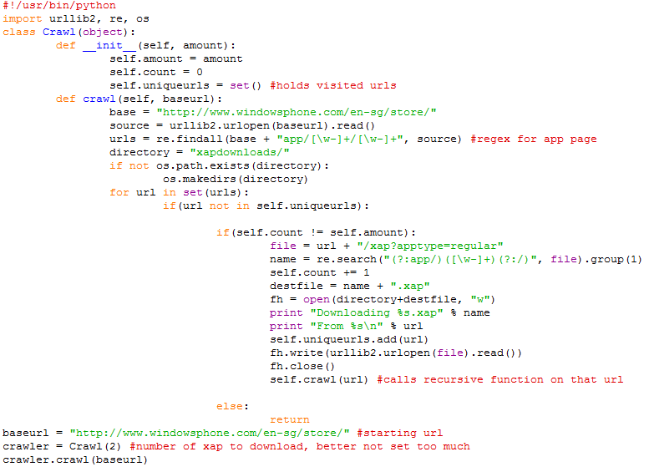

Using python module, urllib2, to fetching urls. In our case, we used regular expression to find the searching pattern for the app page.

The urls for all the apps ends with /xap?apptype=regular and we perform a search for all urls that ends with it. It will download into ‘xapdownloads’ folder and if folder does not exist, will automatically creates a folder called ‘xapdownloads’ and store the files in it.